F

September 2024

**Cervical screening, my way**

Women's attitudes and solutions to improve uptake of cervical screening

July 2024

Contents

Contents 1

Executive summary 2

Introduction 7

Methodology 13

Chapter one 16

Chapter two 24

Chapter three 34

Chapter four 47

Chapter five 55

Recommendations 67

Executive summary

In 2023, NHS England set a target to eliminate cervical cancer by 2040. It's an admirable but challenging goal, set against declining levels of uptake by women of cervical screening over the past 20 years.

In response, Healthwatch England launched research to investigate why some women are hesitant to go for screening, to make recommendations to policymakers on how to improve uptake and to help meet the elimination goal.

Conducted between November 2023 and February 2024, our research consists of:

* A poll of more than 2,400 women who were hesitant about cervical screening.
* Interviews of 30 younger, disabled, or minority ethnic women to amplify voices that are not always heard and who generally face service barriers.

Report findings:

* The top reasons for hesitancy among respondents were worries about physical discomfort, embarrassment at undressing in front of healthcare professionals and a belief they didn't have to go because they weren't currently sexually active.
* Women felt NHS information describing the purpose of cervical screening was good/clear (78%), but fewer (58%) said it explained Human Papillomavirus (HPV) as the leading cause of cervical cancer.
* Some women didn't receive accessible or translated information to enable them to understand the invitations and make an informed decision about attending a screening.
* Most women (81%) who'd attended screening previously said that staff treated them with respect. However, only a third (33%) felt they'd been able to ask staff for practical changes that could make them feel comfortable in appointments.
* There was strong support (73%) for home testing – currently being considered as an option by screening experts – if it was offered free on the NHS.
* Major gaps in national data on the diversity of women who attend cervical screening.
* Examples of innovative practices that improve uptake among diverse women.

Key recommendations

1. NHS England to investigate solutions to ensure that disability and ethnicity data about people attending screening can be captured, analysed, and published alongside regional and age uptake data in the future. This would allow for a more comprehensive picture of uptake among diverse groups.

1. NHS England to address the gap left by the closure of Jo's Cervical Cancer Trust (the only charity and national helpline dedicated solely to cervical cancer), with high-profile promotion of alternative, trusted sources of direct support and information for women.
2. Screening providers to ensure they train and enable admin and screening staff to meet their responsibilities regarding accessible information and adjustments to care.
3. Screening providers, working with local Healthwatch, to seek feedback from their local communities to understand views on booking methods, appointment times and preferred locations for drop-in clinics. Services should adapt access accordingly to help increase uptake.
4. NHS England to introduce an NHS-branded Trauma Card, based on a Healthwatch Essex initiative for affected women to bring to appointments.
5. Subject to the results of NHS-commissioned research on the safety and effectiveness of self-screening, the NHS should adopt self-screening as an alternative option offered to all women nationally who would prefer it. Instructions for their use should be co-designed with women.

Introduction

This report presents the findings of new Healthwatch research, including a poll and in-depth interviews, about women’s views and experiences of cervical screening. It is published against a backdrop of declining levels in uptake of screening invitations in England.

We aimed to:

* Gather the views of women who were unlikely or unsure about whether to attend their next cervical screening appointment.
* Establish the top causes of hesitancy, whether personal or cultural beliefs, knowledge, and awareness of cervical cancer and screening, or the way services delivered the screening contributed to this hesitancy.
* Understand previous experiences of screening.
* Explore in more depth the experiences of young, disabled or minority ethnic women – groups that previous research has suggested may face more barriers or be more reluctant to attend.
* Identify the key changes or solutions that women believed would help increase their likelihood of attending the screening.

Background

England’s national cervical screening programme, which began in the 1980s, aims to prevent women from developing and dying from cervical cancer. It is the second most common cancer in females aged 15-44, according to Cancer Research UK [figures](https://www.cancerresearchuk.org/health-professional/cancer-statistics/statistics-by-cancer-type/cervical-cancer#heading-Zero). There are [higher rates among women living in the most deprived areas](https://www.cancerresearchuk.org/health-professional/cancer-statistics/statistics-by-cancer-type/cervical-cancer#heading-Zero) than in the least deprived ones.

Originally, screening involved taking samples from women and sending them to labs for cytology (looking under a microscope for signs of abnormal cells that could become cancer). Many women and professionals referred to this type of screening as ‘smear tests’.

Since 2019, the [national cervical screening programme](https://www.gov.uk/guidance/cervical-screening-programme-overview) has first checked for Human Papillomavirus (HPV). If HPV is found to be present, the sample is then examined under a microscope for signs of abnormal cells.

To complement screening efforts, HPV vaccination has been offered to all girls aged 12-13 since 2008 and to boys in the same age group since 2019. It is also recommended for at-risk groups, such as men aged under 45 who have sex with men or sex workers.

Women aged 24-49 are now invited for screening every three years, while women aged 50-64 are asked every five years. People who were born with a cervix and who have transitioned to live with a different gender identity, such as trans men – are also eligible for screening.

Most women go to NHS GP surgeries for cervical screening appointments, carried out largely by nurses. If surgeries don’t have necessary equipment like hoists for women with disabilities, these women might be referred to a clinic elsewhere that can meet their needs.

Women can also go to sexual health clinics (which have mostly been commissioned by local authorities but are also being arranged by NHSE in some areas). Cervical screening is [believed to save around 4,500 lives a year](https://view-health-screening-recommendations.service.gov.uk/cervical-cancer/).

[A new target to eliminate cervical cancer in England by 2040 was announced in November 2023 by NHS England chief executive Amanda Pritchard](https://www.england.nhs.uk/2023/11/nhs-sets-ambition-to-eliminate-cervical-cancer-by-2040/).

NHSE said it hoped to achieve this by making it as easy as possible for people to get vaccinated against HPV as well as increasing cervical screening uptake.

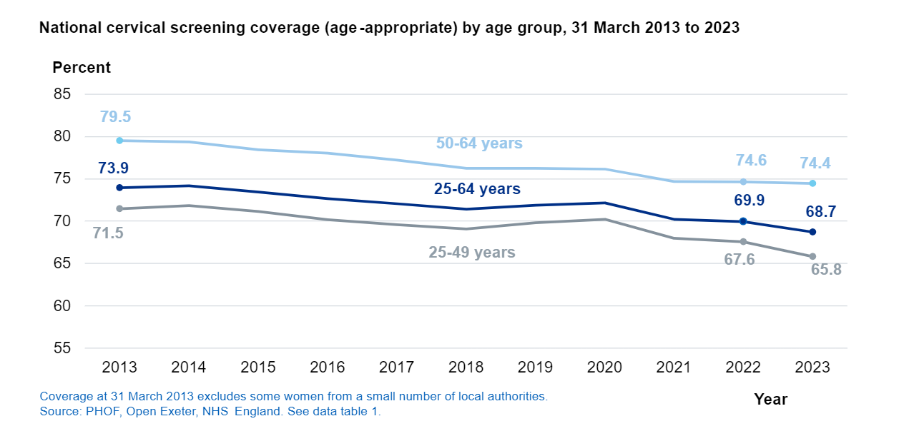The goal, according to the latest data from NHS England, followed a steady decrease in the number of eligible women who underwent cervical screening in England.

Figure 1 **Source:** [**Cervical Screening Programme, England - 2022-2023**](https://digital.nhs.uk/data-and-information/publications/statistical/cervical-screening-annual/england-2022-2023/section-1-call-and-recall) **(national statistics), NHS England, 2023**

Between March 31, 2022, and March 31, 2023, just over two-thirds (68.7%) of eligible women were screened, below the national target of 80% and the lowest since 2014, when coverage stood at 74.2%.

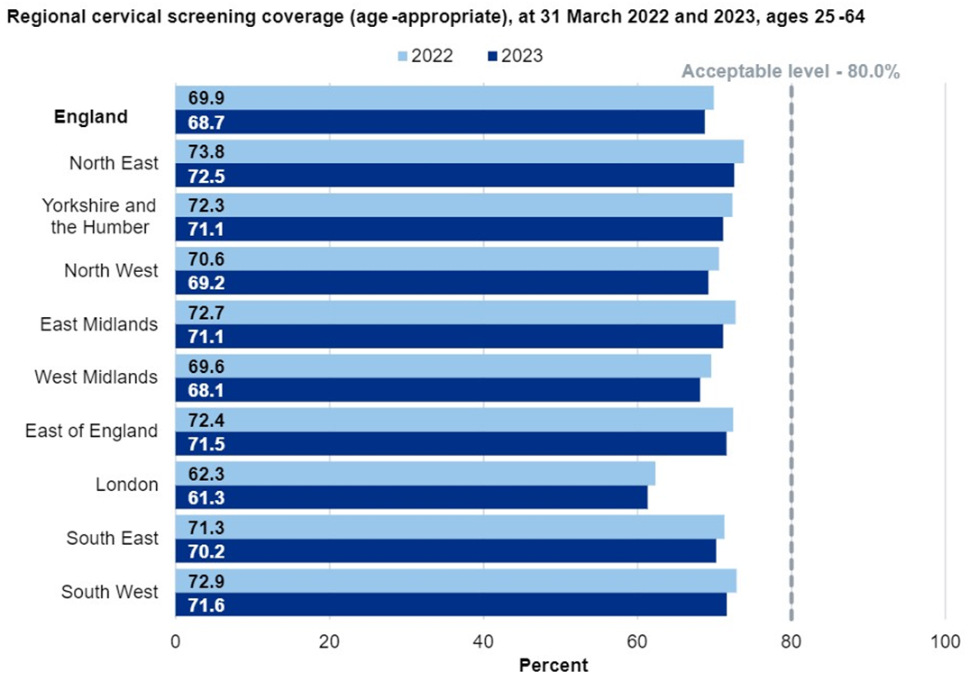The chart above illustrates this trend for each of the three main age groups, with younger women persistently showing the lowest uptake.

Figure 2 **Source:** [**Cervical Screening Programme, England - 2022-2023**](https://digital.nhs.uk/data-and-information/publications/statistical/cervical-screening-annual/england-2022-2023/section-1-call-and-recall) **(national statistics), NHS England, 2023**

No local authority area or integrated care system met the 80% target, and in 13 areas, fewer than 60% of eligible individuals were screened. Almost 250,000 referrals were made to send women for colposcopy (a diagnostic procedure to examine the cervix), an increase of 5% from the previous year.

NHS data has never included national uptake rates by women’s ethnicity. However, a [2022 study by Cambridge researchers](https://www.ncbi.nlm.nih.gov/pmc/articles/PMC9600812/#:~:text=Women%20from%20Black%2C%20Asian%20and,(LDs)%20than%20other%20women.) concluded that “a significant proportion of cervical screening non-attenders are of Black, Asian and other minority ethnicity.”

The most recent [national NHS data published about uptake in women with learning disabilities](https://webarchive.nationalarchives.gov.uk/ukgwa/20171011011112tf_/http:/content.digital.nhs.uk/catalogue/PUB22607/Health-care-learning-disabilities-2014-15-summary.pdf) in 2014-15 showed only 30% were covered.

Other disparities, highlighted previously by a national charity, include lower uptake by women who [have experienced a sexual assault](https://www.jostrust.org.uk/node/1075195) and barriers to attending faced by [physically disabled women](https://www.jostrust.org.uk/our-research-and-policy-work/our-research/barriers-cervical-screening-physical-disabilities).

Methodology

Our research, which was carried out between November 2023 and February 2024, adopted a mixed-method approach to build a comprehensive picture of why some women are hesitant to take up cervical screening opportunities.

First, we commissioned [polling and research agency Savanta](https://savanta.com) to ask women aged 24-64 how likely they were to book their next screening appointment when invited. Only people who responded, 'don't know,' 'somewhat unlikely', or 'very unlikely', completed the full survey, with 2,444 responses gathered in total.

This number includes a boost sample of 400 minority ethnic women to capture a statistically significant number to compare their experiences with White women, given that national NHS figures do not look at these differences.

Polling questions covered these themes:

* Reasons for hesitancy
* Past screening experience
* Information and awareness about cervical screening and HPV
* Views on potential solutions to overcome hesitancy
* Views on home self-sampling

We also commissioned 10 local Healthwatch to undertake in-depth interviews with women to enable themes to be explored and to understand their experiences in greater detail. Interviews were undertaken with 30 women made up of:

* Nine women from minority ethnic backgrounds
* Nine women with learning disabilities
* Four women with physical disabilities
* Eight young women aged 24-29

We targeted these types of women because of disparities of experience suggested by past research and to amplify the experiences of people who are not always heard.

The interviews were carried out by:

* Healthwatch Blackburn with Darwen
* Healthwatch Blackpool
* Healthwatch Brighton and Hove
* Healthwatch Central Bedfordshire
* Healthwatch Greenwich
* Healthwatch Lambeth
* Healthwatch Liverpool
* Healthwatch Redbridge
* Healthwatch Surrey
* Healthwatch York

Terminology used in this report

At Healthwatch England, we champion inclusivity and equality in all we do as an organisation. All people eligible for cervical screening will have been assigned as female at birth and have a cervix.

However, we also recognise the experience of diverse gender identities and that people eligible for screening don’t just include women but also people who identify as ‘trans men’ or ‘non-binary’.

We asked our polling respondents and interviewees about sex and gender. All our interviewees and 99% of our poll respondents described themselves as ‘women’.

The percentage of poll respondents who described themselves as a gender other than ‘women’ in our poll was not statistically significant enough to report findings broken down by their gender.

Therefore, we have primarily used the terms ‘women’ or ‘people’ in this report.

Chapter one

Have women hesitant to attend cervical screening received the information they need?

To assess why some women may be reluctant to take up screening, we first explored what they knew and understood about the purpose of screening and HPV.

The key information source is in invitation letters sent out by the national screening programme to women every three or five years (there is also information on the NHS website).

NHS England’s screening specification says these letters should give women ‘the information they require, in an accessible format, so they can make an informed choice about whether or not to participate in the screening programme’.

Invitation letters, therefore, represent an important opportunity to dispel any misconceptions women may have and inform them about facts they may be unaware of, such as:

* Screening still being necessary if you’ve had the HPV vaccination (because the vaccine doesn’t cover all types of HPV)
* How HPV is spread (not just by vaginal sex, but other types of sexual contact)
* How long HPV might stay in your body before developing into cancer (in some cases, years after your last sexual contact)

Getting information from the NHS

Over three-quarters (78%) of women answering our poll had received information from the NHS about cervical screening.

Of these:

* 90% said the information explained the purpose of screening
* 83% said the information was easy to understand
* 76% said that the information explained what the appointment involved
* Only 58% said the information explained HPV.

A significantly higher number of Asian (22%) and Black women (18%) than White women (12%) said they did not receive information from the NHS about cervical screening.

Over a quarter (26%) of Black respondents said NHS information did not explain what HPV was, compared with 19% of Asian and 15% of White women.

Nearly a quarter (23%) of younger women aged 24-29 said NHS information did not explain HPV, compared with 11% of women aged 60-64. Further research is required to establish the reasons behind these differences.

Prior knowledge from other sources

Women we interviewed described how growing up outside of England could affect their awareness of cervical cancer and screening.

A woman from a South Asian background described this in her own words:

“Cancer is sort of like a taboo thing back home… my mum did teach me a lot of things, but I think we all come from, like, a society where it's a bit, we can't talk about it openly. And even if we do, we search for women like our mum or our grandmother. Maybe very close friends, but we don't necessarily make it a topic of discussion. We do it like we whisper about it or something like that.”

* Woman from a minority ethnic background interviewed by Healthwatch Greenwich

A young woman who was raised in East Asia shared a similar experience:

“I didn't know. I got [information about] the procedure from my friend because my friend came to the UK earlier than me, so I heard about the experience from my friend. “

* Woman from a minority ethnic background, interviewed by Healthwatch York

According to the World Health Organization, 133 out of 194 countries have national cervical cancer programmes, but they vary - with some having only HPV vaccination but no cytology or HPV screening.

Developing nations make up many of the 61 countries with no programme.

Preferred sources of information

Women who told us in our poll that they had not, or were unsure whether they had, previously received information from the NHS (532 out of 2,444 respondents) were then asked where they would like to ‘find information about cervical screening in the future’.

The top three choices were:

* The NHS website (41%)
* The NHS App (25%)
* Their GP surgery (20%).

According to poll respondents, email (19%) and appointment letters (18%) were also important sources of information.

However, disabled people in our in-depth interviewees stressed that appointment letters needed to be accessible, including one woman who said:

“The NHS only sent one letter, and it was in small print. This made it hard for me to read as I have a learning disability and severe visual impairment. I gave it straight to my sister-in-law, my legal guardian, and she read it to me. She booked the appointment and then took me to the screening. I requested them to give the letters in a larger font several times, but I was ignored and put to one side constantly.”

* Disabled woman interviewed by Healthwatch Redbridge

The NHS Accessible Information Standard places a legal duty on providers to ensure that disabled people and those with sensory needs, such as visually impaired or Deaf people, receive information in alternative formats via the NHS England Customer Contact Centre to make it as straightforward as possible.

NHSE says patient letters were reviewed and changed in December 2023, including an increase in font size in line with RNIB recommendations.

Our [previous research about the lack of AIS compliance](https://www.healthwatch.co.uk/news/2023-07-10/our-policy-position-accessible-information) has influenced a review and proposed changes to the AIS, but it has yet to be published.

Overall, our findings suggest that the NHS needs to review its information on HPV and test its key messages on screening with diverse women to ensure it is understood by all, regardless of age, disability, or heritage.

A variety of information sources are also required, whether digital (websites, the NHS App), traditional (letters sent in the post) or in-person (community outreach sessions). We’ve heard from the Healthwatch network about innovative practices in educating and informing women.

These include the [Rumworth Project led by Healthwatch Bolton](https://www.healthwatch.co.uk/news/2023-01-20/breaking-down-barriers-life-saving-screenings), which involves GPs, a primary care network, a cancer charity, and local mosques working together to run outreach clinics to help women get information about familiar environments.

This resulted in more women agreeing to undergo cervical screening. Healthwatch Islington also hosted an [information workshop](https://itservicemanagementcqcorg-my.sharepoint.com/personal/rebecca_curtayne_healthwatch_co_uk/Documents/Desktop/%E2%80%A2%09https:/www.healthwatchislington.co.uk/advice-and-information/2023-11-16/questions-and-answers-cervical-screening) between a lead nurse and staff from organisations supporting women from minority ethnic communities to share information and dispel myths.

Chapter two

How have women hesitant to cervical screening found previous screening experiences?

Attitudes towards screening are also likely to be affected by previous experience of the process. We therefore investigated how women who are hesitant found their last experience of screening.

More than half (58%) of the participants in our poll had attended a cervical screening appointment before. We asked women about past experiences to identify issues that could affect their willingness to be screened in future.

Respondents were asked to agree or disagree with a series of 12 statements covering various aspects of the process, with findings shown in the table below:

|  |  |  |
| --- | --- | --- |
| **Statement about past experiences of screening** | **% Net agree** | **% Net disagree** |
| I was given privacy when removing my clothes | 83% | 6% |
| Staff treated me with respect throughout | 81% | 7% |
| The procedure was explained to me in a way I understood before it took place | 76% | 11% |
| During the procedure, all steps were clearly explained to me | 70% | 14% |
| I was aware that I had a right to have a chaperone present | 54% | 25% |
| I felt able to end the appointment at any time if I needed to | 46% | 25% |
| Staff accommodated my access needs (e.g. information in a format I could understand, helped me onto the examination couch) | 45% | 9% |
| I was aware I could wear a long skirt or other covering at the appointment | 44% | 32% |

|  |  |  |
| --- | --- | --- |
| **Statement about past experiences of screening (continued)** | **% Net agree** | **% Net disagree** |
| I felt able to ask for changes, e.g. to change my position for comfort to use a smaller speculum (the instrument used to collect the sample) | 38% | 33% |
| Any requirements I had for extra time were met | 36% | 12% |
| During the screening appointment, I experienced little or no discomfort | 36% | 49% |
| Staff respected my religious or cultural needs | 33% | 4% |

We discuss these findings in more detail below, including differences between diverse women.

Being treated with respect

It is positive that 81% of women in our poll who’d previously attended screening said that staff had treated them with respect.

In our interviews, women also described positive experiences of staff who were reassuring, listened to them and offered solutions to their concerns.

However, disabled women in our poll were more likely (8%) to disagree with the statement about being treated with respect compared with non-disabled women (5%).

In interviews, women with physical and learning disabilities described situations where they had been shouted at, had not been given extra time to get up on the examination couch, or had been told off for coming in for screening at the “wrong” time of their menstrual cycle.

As one interviewee described, in her own words:

“Well, … one of [the] staff, … she didn’t mean to, but she shouted at me … because I think she was just stressed … so she just shouted at me and … She kept asking me, do you want to do it or not? I was like, “I don’t know”. I kept saying, “I don’t know”.”

* Woman with learning disabilities interviewed by Healthwatch Blackpool

Physical discomfort

Cervical screening is, by necessity, an invasive procedure that many find undignified, embarrassing and potentially uncomfortable.

It is unsurprising that nearly half (49%) of participants disagreed with the statement that during the screening appointment, they experienced little or no discomfort.

However, this was higher for disabled women (54%) than non-disabled women (47%).

[Information on the NHS website suggests](https://www.nhs.uk/conditions/cervical-screening/what-happens/) ways women can make themselves more comfortable during the cervical screening procedure. They can ask to change their position when screening takes place, ask for a smaller speculum to be used, and wear a skirt or other covering.

However, a higher proportion (37%) of disabled people in our poll felt they couldn't ask for changes compared to non-disabled people (30%).

This could be due to not having a trusted friend or supporter in the room to help them ask for these changes, a previous experience putting them off asking for help or not being made aware of these options by the healthcare professional.

In the interviews, women described the discomfort they experienced when the wrong size speculum was used, and they were not pre-warned that this could cause pain. By contrast, knowing that they could ask for different size speculums or being offered the choice was a positive factor in some women feeling able to take up cervical screening again:

As one interviewee described, in her own words:

“I know for a fact what really helped me last time when I went was that the nurse after it had been done, told me the specific speculum that would suit my cervix the best for the future. When I first went, there were a couple of different ones she had to try out. That added to the anxiety of it. Because you have to test different ones, and that motion of in and out was uncomfortable. Knowing that, to be able to tell someone for the future, would be really helpful."

* Young woman interviewed by Healthwatch Central Bedfordshire

Pain and discomfort during screening are particularly a problem for women who have had previous trauma or experienced pain more acutely.

We heard from women with a prior history of sexual abuse, women with learning disabilities or autistic women who had particularly painful experiences with cervical screening.

Common to all these experiences is poor or a complete lack of communication between the woman and the health professional carrying out the procedure:

“As a person with a learning disability, I often forget information from previous procedures that I have already experienced. The lack of communication from the health professionals makes my brain panic, and my body freezes up on me, making the whole experience even more painful. They insert the clamp too fast, with no warning. This also makes me extremely anxious."

* Woman with a learning disability interviewed by Healthwatch Redbridge

“An empathic nurse can make all the difference", said one young woman in our interviews. The nurse said she could stop at any point, have anti-anxiety medication the next time, and a colleague could come in and hold the woman's hand during the procedure…And I remember thinking I didn't know that was an option. I mean, that sounds great, didn't need it in the end, that's fine."

* Woman, interviewed by Healthwatch Brighton and Hove

Not feeling in control

Being able to cover the lower half of their bodies can make women feel less embarrassed during a cervical screening appointment. But nearly one-third (32%) weren’t aware they could do that:

“I know when I went in for my screening, I did find it really weird that you are basically naked from the waist down. And I wasn't given-, you know, on TV, there's that very papery looking blanket thing that you have covering you. There was nothing like that and I found that really odd. I didn't totally love that, it made me feel quite vulnerable.”

* Young woman interviewed by Healthwatch Brighton and Hove

Feeling in control may also mean being able to end appointments when needed and having someone with the patient for moral support.

It is worrying that a quarter of the respondents felt they couldn’t end the appointment if they needed to, and a further quarter weren’t aware that they could request to have a chaperone present.

“My sister-in-law took me to my cervical screening, but they would not allow her to come into the room. I wanted my legal guardian to be present during the screening, but they did not let her. I was put into the room myself.”

* Woman with learning disabilities interviewed by Healthwatch Redbridge

Accessibility

People going for screening may have different access needs, such as communication needs, wheelchair-accessible buildings and examination rooms, and the need for extra time during appointments.

In the interviews, disabled women described situations where they were keen to have cervical screening appointments, but the buildings and equipment were not accessible.

They also described situations where the healthcare professionals didn’t read their notes and anticipate their needs.

One woman, who sometimes uses a wheelchair, said:

“I mean the number of professionals who just go, oh, hop up here’, I’m going ‘I’m terribly sorry, but I can’t hop anywhere, good luck with that’. But in the back of your head, you’re thinking you should be able to, so you try, and then you go and actually, no, I probably shouldn’t have done that. And, then you go, actually, excuse me, could you lower it when actually they should be ahead of you.”

* Woman with physical disabilities interviewed by Healthwatch Liverpool

We also found that 15% of disabled women in the poll disagreed with the statement that any requirements they had for extra time during the cervical screening appointment were met, compared to just 10% of non-disabled women.

Chapter three

How high are levels of hesitancy and what are the reasons given for it?

Our research does not seek to provide an overall number of women across England who are hesitant to cervical screening. [Official data](https://digital.nhs.uk/data-and-information/publications/statistical/cervical-screening-annual/england-2022-2023) shows that out of 16.24 million people eligible for screening, only 11.6 million women (68.7%) were screened.

However, our research does provide an indication of how strong feelings are on screening hesitancy and why.

Level of hesitancy

Our total poll sample of 2,444 women varied in their level of hesitancy about cervical screening. When asked whether they would attend their next appointment when invited, less than half of the respondents (41%) answered ‘don’t know’, 33% said they would be ‘somewhat unlikely’ to attend, and only 26% said ‘very unlikely’.

We found that a higher proportion of White women (28%) said they were ‘very unlikely’ to attend compared with Black (24%) and Asian (17%) respondents.

This could be because our sample had more White respondents with an even age spread. Ethnic minority respondents were more likely to be aged under 39 and part of an age group more likely to answer, ‘don’t know’.

Older women aged 60-64 also said they were ‘very unlikely’ to attend their next appointment compared with other age groups, reflecting that they were reaching the age 64 cut-off point for the national screening programme.

A higher number of disabled women (32%) than non-disabled respondents (22%) also were ‘very unlikely’ to attend, which could be due to concerns about services not adjusting for their needs.

The overall number of ‘undecideds’ and relatively low number of those answering ‘very unlikely’ to attend suggests there is potential to convince women to attend.

Reasons for hesitancy

We asked respondents to select all the reasons for being hesitant about screening from a list of 11 statements. The table below shows these findings.

|  |  |
| --- | --- |
| Selected reason | **% of respondents selecting** |
| I'm worried that the examination will cause me physical discomfort | 38% |
| I'm embarrassed at having to undress in front of a healthcare professional | 26% |
| I'm not currently sexually active so don't feel the need to go for cervical screening | 21% |
| A past traumatic experience unrelated to cervical screening has put me off | 15% |
| I'm worried about getting the results of the screening test | 14% |
| I don't have the time to attend a cervical screening appointment due to other commitments | 10% |
| I can't book an appointment at my GP surgery as I can't get through to it on the phone | 9% |
| Selected reason | **% of respondents selecting** |
| Cervical screening appointments aren't available at times that are convenient for me | 8% |
| I'm too old for a cervical screening appointment | 7% |
| I was told there was no need to attend one by a health professional | 6% |
| I don't think cervical screening is effective | 5% |

We found significant differences between women who’d never attended screening previously after being invited by the NHS with those who had attended after receiving their screening invitation on the following reasons:

* Physical discomfort (50% who’d never gone versus 32% of those who had).
* Embarrassment (42% versus 18%).
* Not needing to go due to lack of sexual activity (26% versus 18%).
* Being worried about what the results will show (20% versus 11%).

This shows the importance of services in assuaging the fears of women as they embark on their screening journey at the time of their first invitation or consistently choose not to attend.

Pain, fear, trauma and anxiety

The hesitancy reason reported by most respondents was a worry about screening causing physical discomfort. We found that this was a greater concern for disabled women (43%) than for non-disabled women (36%) and younger women in the 24-29 age group (44%), compared with 31% of women aged 60-64. Black women were slightly less (33%) worried about discomfort than White and Asian women (39% each).

One young woman said:

“I have problems like down there. I don't like having stuff being done. I've been for a speculum test, and I know it's not the same, but it's similar, and they’ve taken light swabs. They've been really uncomfortable for me. Really uncomfortable to the point where I started crying my eyes out, and I had to stop halfway through. So, it makes me feel nervous.”

* Young woman interviewed by Healthwatch Blackburn with Darwen

Cervical screening also contained an element of fear for some participants, whether related to the potential for bad news (testing positive), having vaginismus (a condition where your vaginal muscles involuntarily tighten when you try to put something inside your vagina, which can cause burning or stinging pain) or experience of past trauma.

A young woman with vaginismus explained:

“The last one I went to, three or four years ago, wasn’t traumatic, but I found it really stressful. Not from anyone doing anything to me that I found really uncomfortable, just more so because of my own anxiety around it, and that I generally find them pretty painful. That’s what is putting me off doing it just now.”

* Young woman interviewed by Healthwatch Central Bedfordshire

The effect of past trauma was also captured in this comment from a young woman:

“I also have a bit of history of sexual abuse, and it made me a bit – not especially with any kind of intimate exam or anything – but I’ve had times at the doctor where I felt like the doctors or nurses, or healthcare assistants aren’t always particularly compassionate. And aren’t always particularly cognisant of the fact that they’re saying, ‘it doesn’t hurt’. But what they’re doing does hurt, and I felt a bit nervous about going in for this procedure.”

* Young woman interviewed by Healthwatch Brighton and Hove

Healthwatch Essex has developed an innovative approach to supporting women affected by trauma. Its staff created a film in partnership with a GP surgery to help educate professionals about ‘trigger points’ for women who had experienced past trauma during cervical screening appointments.

Healthwatch Essex has also produced [a Trauma Card](https://healthwatchessex.org.uk/trauma/) that patients can use as a prompt for discussions with health professionals. Trauma cards are now being [used by thousands of people across England and even abroad](https://healthwatchessex.org.uk/2023/10/trauma-survivors-across-essex-launch-film-to-improve-uptake-of-cervical-screening/).

Culture, family and beliefs about sexual activity

The hesitancy reason reported by most respondents was a worry about screening causing physical discomfort.

We found that this was a greater concern for disabled women (43%) than for non-disabled women (36%) and younger women in the 24-29 age group (44%), compared with 31% of women aged 60-64. Black women were slightly less (33%) worried about discomfort than White and Asian women (39% each).

A woman who grew up in another country before coming to England said:

“It is 100% societal influence, influence and the culture that we are from that women…don't really talk about it as much and we're shy about it. We feel like there's some guilt about it, like having your period or even pregnancy.”

* Young South Asian woman interviewed by Healthwatch Greenwich.

This ‘shyness’ could explain why more Asian respondents (30%) than White (26%) or Black (20%) women in our poll cited embarrassment at having to undress in front of a healthcare professional as a reason for hesitancy about screening.

A young woman also described beliefs that screening could ‘take’ your virginity (which, for some people or cultures was important to retain before marriage).

“There's a lot of people who think that you shouldn't be inserting things into your vagina before marriage because of the whole hymen thing. You bleed or you don't bleed, it doesn't matter. A lot of people are going to be like, ‘no it's not right, it's wrong’. I personally don't believe that. And none of my family does either.  It's important, but unfortunately, not everyone shares that belief, so it's that cultural kind of fear that we're not sexually active so we don't want to have anything inserted.”

* Young woman interviewed by Healthwatch Blackburn with Darwen

We also heard that some disabled women who may rely on family or friends to tell them about screening because services don’t provide accessible information – may be told incorrect information.

One woman said her mother had told her that screening was only for women with a long-term partner. This led her to believe that “it’s for ladies with a man”.

This runs contrary to official public health information. The [NHS website](https://www.nhs.uk/conditions/human-papilloma-virus-hpv/) explains that HPV – which screening is looking for – can be caught without having penetrative sex, through other types of activity such as oral sex or skin-to-skin contact in the genital area. HPV can also stay in your body for years after being sexually active.

The Eve Appeal, a charity offering support to women over five gynaecological cancers, has [tips on cervical screening](https://eveappeal.org.uk/gynaecological-cancers/cervical-cancer/facts-and-tips-for-cervical-screening/?gad_source=1&gclid=CjwKCAjwg8qzBhAoEiwAWagLrPOfqx9RtDd_mbNf_vIaMpImOiBtSAdXiBCutycVotMgqCih_MjqcxoCKZUQAvD_BwE) that explain that women who have sex with women and trans men are also eligible for screening.

Experiences shared with us illustrate the need for more education about how HPV can be transmitted, myth-busting around virginity and who is eligible for screening.

Past medical procedures

In our poll we also received 32 free text responses from women who selected ‘other reasons’ for hesitancy. Most of those related to having had a hysterectomy and sometimes confusion about whether this affected their eligibility for screening:

“I’ve had a hysterectomy but a couple of years later was invited to attend screening so showed up only to be told once [they were] poking around they had trouble doing so, then [was asked] if I had had a hysterectomy. I was not told once having one I wouldn’t have to have smear tests. Surely, I’m still at risk of cancer?”

* Free text comment from poll respondent

This suggests the need for clearer information for women in screening invites and after any procedures that would exclude them. It also raises the issue of whether the IT infrastructure—or guidance—exists for GP surgeries and sexual health clinics to easily update or inform the national screening programme database about women no longer eligible for screening so they don’t get sent invitations unnecessarily.

The impact of other health issues or diagnoses

The following free text comments from our poll described how physical problems or being neurodivergent made screening difficult:

“I have osteoarthritis in my hips and AS. This makes lying on my back impossible when explained to the nurse at a medication review, she didn't advise me on any further action.”

* Free text comment from poll respondent

“I am housebound and also unable to get into the appropriate position due to disabilities.”

* Free text comment from poll respondent

“Being Autistic I find the experience overwhelming due to overload on sensory input. Not being able to express how things such as being touched, being cold, bright lights and often impersonal.”

* Free text comment from poll respondent

We also received a small number of free text comments from people concerned that HPV screening wasn’t adequate:

“I was HPV negative on my last test, I will not have contracted it since. To tell me I’m HPV negative again, with no further cell examination to be carried out, is a waste of resources. I feel the cell examination is vital, even with an HPV negative test.”

* Free text comment from poll respondent

When changes to cervical screening were announced in 2016, [the Department of Health and Social Care said](https://www.gov.uk/government/news/changes-to-cervical-cancer-screening) that ’99.7% of cervical cancers are caused by persistent HPV infection’.

Previously, when samples were looked at to detect abnormal cells, these were sometimes missed, or normal cells were misdiagnosed, causing unnecessary further tests and anxiety for women.

Chapter four

What do women hesitant about cervical screening think about the option of home testing?

A key goal of our research was to identify solutions to encourage more women to present for screening.

One solution being considered by the national screening programme is home testing, more formally known as ‘self-screening’ or ‘self-sampling,’ so we investigated views on this.

What is home testing?

Unlike the procedure at a GP surgery or sexual health clinic, home testing does not involve a speculum or the woman needing to reach their cervix.

Instead, the woman uses a swab, like a long cotton bud, to collect a sample from their vagina, where HPV can also be found.

Under a pilot study [called](https://www.smallc.org.uk/get-involved/get-involved-youscreen/) YouScreen, which ran in 2021, 31,000 women in London who were at least six months overdue for their latest cervical screening appointment were sent home testing kits directly or invited to take part by their GP surgery.

Women received instructions and a link to a video showing them what to do. Around 8,000 people took part.

[Results](https://www.kcl.ac.uk/news/self-sampling-hpv-kits-could-screen-an-extra-million-people-for-cervical-cancer) published in July 2024, showed 8,838 people sent back self-samples; 64% of whom were from ethnic minority groups and 60% from deprived populations. More people (56%) returned a kit when it was offered to them by their GP practice than when it was mailed directly to them (13%).

The UK National Screening Committee has also overseen [a study called HPValidate](https://nationalscreening.blog.gov.uk/2023/06/21/hpvalidate-cervical-screening-self-sampling-study-nears-completion/), which is collecting 5,000 samples from general practice and 1,750 samples from colposcopy clinics to determine the accuracy of vaginal self-samples compared to clinician-taken samples.

This study is referenced in the Women’s Health Strategy, along with the potential of home testing to address barriers, including ‘availability of appointments, physical disability and past trauma’.

According to research, around 12% of countries with screening programmes use this approach. Of these 17 countries, nine use it as a primary form of collection, including [Australia](https://www.health.gov.au/self-collection-for-the-cervical-screening-test), and eight use it to reach under-screened populations.

Our findings on home testing

Our polling shows that the vast majority (73%) of women hesitant about screening would be likely to use a ‘home testing kit’ if it was available for free on the NHS. Nearly all (96%) said they’d never bought a home testing kit, which is sold online for between £29 and £129.

This figure is higher than findings in a [2022 UK survey published in the Journal of Medical Screening](https://www.kcl.ac.uk/news/research-suggests-over-half-of-eligible-women-would-prefer-self-sampling-for-cervical-screening), which showed 51% of women would prefer home testing, compared to 37% who wanted it still to be carried out by a clinician.

In our poll, support for home testing was slightly higher among White respondents (75%) than among Black, Asian, Mixed, Multiple, or Other ethnic backgrounds (70%).

Women aged 30-39 reported significantly increased interest (76%) than women in the 60-64 age group (68%), while support for home testing was around the same between disabled (75%) and non-disabled (74%) respondents.

Perceived benefits and disadvantages

We asked poll participants whether they agreed with a series of statements about the potential pros and cons of home testing. The key findings were:

Benefits:

* Privacy (53%)
* Avoiding discomfort (52%)
* Easier to find time (47%)
* No need to book (43%)
* Past negative experience (27%).

In our in-depth interviews, most of the women said using home testing would be convenient, and they would like to do it at home in their own time, without having to book an appointment or get undressed in front of strangers

“I would feel quite comfortable doing that…. Sometimes, it does come down to convenience, and if you’re told properly how to do it, then you can do it more.”

- Young woman interviewed by Healthwatch Surrey

Another interviewee also stressed the importance of being given clear instructions and having the choice between self or clinician-led sampling:

“I’d love it! I wouldn’t have to go anywhere, I can do in my own time, I don't have anybody looking at my body. Like I’m not the most confident about my body. I’d love it! As long as I had like instructions and firstly the video description of what I have to do and when. I think there should be an option to choose whether you would you prefer to go to your GP or would you prefer to do it at home.”

- Young woman interviewed by Healthwatch Blackburn and Darwen

One woman also could see the potential of home testing being a benefit for people who didn’t find it easy to travel to appointments.

“I can see that for people who, with chronic pain and chronic fatigue as well, and a lot of other issues, I’ve got a great friend and sometimes she just can’t get out, so if you can’t, the home testing is a far better system than that person being reliant on having to get to the appointment, crossing half the city in order to get to an appointment when they’re just really not up for it.”

- Woman with physical disabilities interviewed by Healthwatch Liverpool

Disadvantages:

* Concern about accuracy (41%)
* Cannot ask anyone if you’re doing it correctly (31%)
* Concern about follow-up testing if the result was abnormal (17%)
* May not work (10%).

Women with physical and learning disabilities were more likely to say in the interviews that home testing wouldn’t be for them because:

* It wouldn’t be practical
* It might be painful
* They would need someone else to do it for them
* Or they would prefer a healthcare professional carrying it out

Other interviewees raised a variety of concerns, including worries they wouldn’t do the screening correctly, not wanting to ask a partner for help, lack of privacy or hygiene at home, and having to repeat the process if the results were inconclusive.

“There is something about using the stick that is not for me I'm not comfortable doing it myself, I cannot do it, so would ask my husband to help me.  I think it's my personal reason.”

- Woman from a minority ethnic background, interviewed by Healthwatch York

One woman raised the impact of living environments:

“This is a test that someone has to perform on you so, how would this happen? I don’t think it’s a good idea because of a lot of hygiene [a clean environment]. Here, there are families with many people, and this is a private and personal test. So, you go to the bathroom, you need to know how to do it [the self-screening] and you may not have the correct result because the person doesn’t know how to do it.”

- Woman from a minority ethnic background, interviewed by Healthwatch Lambeth

Women who knew and trusted their health professional said they preferred to keep attending screening appointments.

“I think definitely at the beginning I would have preferred the at home [screening], but my GP is so good, and I’m so relaxed about them now.”

– Woman from a minority ethnic background interviewed by Healthwatch Surrey

Despite the reasons for not opting for home testing, the overall support among women hesitant to screening is positive.

Chapter five

What else could help to improve take-up rates of cervical screening?

We asked women through polling and interviews about what would make them more likely to attend cervical screening appointments in the future.

The polling asked women to assess 11 options for how likely or not each change would influence future attendance, with findings shown in the chart below.

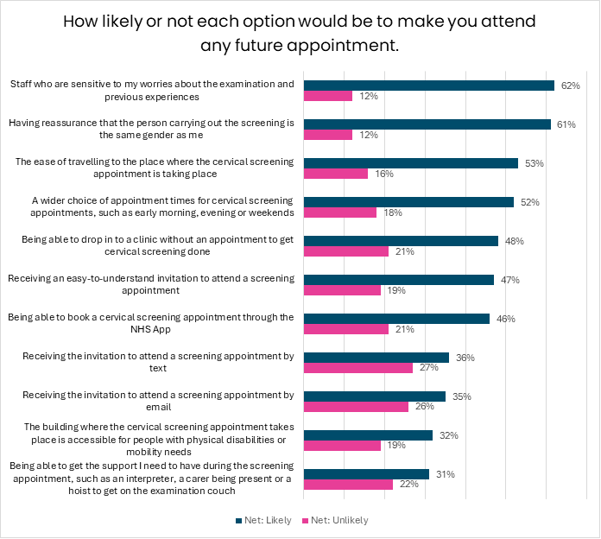

The vital role of staff

As the chart shows, the top change that would make women more likely to attend screenings was sensitive staff (62%).

This is a theme that also came through many of the interviews, especially if women had been anxious about pain, fearful due to past trauma or had extra needs.

The difference that a healthcare professional can make is highlighted in this experience:

“I was dealt with by a health professional who was very understanding of my needs, as I had previously known him from prior appointments. He was already aware of my long-term conditions. This made my experience very comfortable. He spoke to me and my sister-in-law, explaining the procedure step by step. This was a very different experience from my other screenings, as the health professionals previously barely explained the procedure or understood my needs [as] a person with a disability.”

* Woman with learning disabilities interviewed by Healthwatch Redbridge

Other interviewees felt proactive personal contact to remind them to book a screening appointment, discuss any concerns, or the service offering someone to come out to give a talk to their group, would help them book an appointment.

This sounds similar to how some GP surgeries had worked with communities to discuss and answer questions or concerns about Covid vaccination during the pandemic.

“So, if I was to get a call from the GP and say, ‘We notice that you haven't been for your screening, is there a reason?’ I think I would chat to them and then book an appointment. If I get a letter through the post, it feels a bit impersonal, and it’s so easy to put it to one side.”

- Woman from an ethnic minority background interviewed by Healthwatch Surrey

Some women in our interviews suggested training for administration staff booking people in for appointments and professionals carrying their screening, so they would respond appropriately and sensitively to women with physical and learning disabilities.

Having the same gender healthcare professional carry out the screening was the second most important solution women said would help overcome hesitancy.

There is no specific NHS right to a same-gender health care professional, although the NHS Constitution currently includes broad rights for patients to be treated in a safe and dignified way.

These include the right to receive care and treatment that ‘meets your needs and reflects your preferences’, and where this isn’t possible, for providers to explain why and ‘explore alternatives’.

Both the General Medical Council and Royal College of Nursing issue guidance on carrying out intimate examinations which they expect doctors and nurses, respectively, to follow.

[Guidance from the Care Quality Commission (CQC) also states](https://www.cqc.org.uk/guidance-providers/regulations/regulation-10-dignity-respect): “When providing intimate or personal care, providers must make every reasonable effort to make sure that they respect people's preferences about who delivers their care and treatment, such as requesting staff of a specified gender/sex.”

People are also entitled to refuse any care, including intimate examinations, if they wish.

Accessibility

Women in our interviews raised accessibility to a screening venue and invitations to book appointments as areas for improvement.

Some interviewees suggested giving women with physical disabilities the opportunity to have two appointments – one to check out the venue and ask questions of staff, followed by the screening appointment.

They also wanted services to proactively anticipate their needs:

“[They should treat] you a little bit more as a person, or at least make reference to, okay, yeah, we realise you’ve got this that and the other [extra need/disability], what can we do to help?

And frankly, they should have gone through that process before you’re in that situation. … Really there should be something in between like a buffer …where they have a conversation with you about you, what you might need in terms of physical pain, in terms of your mobility”.

* Woman with a physical disability interviewed by Healthwatch Liverpool

Regarding the accessibility of invitation materials, a higher proportion of women from an ethnic minority background said they would be more likely (60%) to attend a cervical screening appointment than White women (43%) if they had an easy-to-understand invitation.

Women in our interviews also raised the need for translated information about cervical screening.

“I think it is important that they send the letter in your language because, for most of the readers, there is a language barrier. It took me time to understand what was in the letter because my English wasn't very good.

I had to use a translating app to understand it. So, imagine the women who can’t speak English and it’s hard to understand the letter, so they just throw it away.”

* Young Somali woman interviewed by Healthwatch Redbridge

We also heard support from women with learning disabilities for videos explaining the procedure beforehand.

**Interviewer:** Do you think videos would be good, so you know what to expect?

**Interviewee:** Yes, they showed a video before I went for a mammogram in the unit, and you couldn’t take your eyes off it. That was better definitely.

**Interviewer:** So, if we had easy read letters, easy-read leaflets to let you know what it’s about and videos too that might help?

**Interviewee:** Yes, I really liked the video. Everyone watched it intrigued. The women were really friendly and fun. They had pink t-shirts with boobs on them!”

* Woman with a learning disability interviewed by Healthwatch Blackburn with Darwen

Support during the appointment

Our poll found that nearly half (47%) of women from minority ethnic backgrounds said being able to get support during appointments – such as an interpreter, having a carer present, or a hoist to get onto the examination couch – would make them more likely to take up their next screening invite, compared with 27% of White women.

The need for support was a theme that also came out strongly in our interviews for women with physical disabilities, autism, and those with a history of sexual trauma.

The latter groups said it was particularly important to be able to choose to bring someone they knew to the appointment, especially if they didn’t want to tell staff about their past.

There is no specific patient right in the NHS Constitution to a chaperone or an NHS-wide definition of chaperones, but we have seen evidence of many organisations having a chaperone policy.

Flexible appointment times

More than half of our poll respondents (52%) said a wider choice of appointment times for cervical screening, such as early morning, evening, or weekends, would help make them more likely to attend future appointments.

Being able to drop into a clinic without an appointment was also important for 48% of respondents. This option was more important for people who said they had one or more children (57%) compared with 44% of respondents with no children.

This shows the importance of screening services knowing what type of women make up their local population so they can consider alternative access models.

During our project, we heard about the opening of [a Women’s Health Hub in Sunderland](https://northeastnorthcumbria.nhs.uk/news/posts/region-s-first-women-s-health-hub-launches-on-international-women-s-day/). The hub aims to offer more accessible access to cervical screening to women living in areas of deprivation, alongside contraception, menopause advice, and health checks.

We also heard that some GP surgeries or clinics offer weekly or monthly drop-in sessions or open access during annual, national cervical screening awareness weeks.

Social networks

Another solution described to us in interviews was the role of more confident women in helping their friends or family change long-held beliefs or concerns about screening.

One young woman who lived with her aunt described coming from a background with a lot of cultural taboos associated with intrusive procedures such as cervical screening and her relative trying to discourage her from screening.

“Some people were saying, you know, are you not scared that when you get married, they're going to know that you're 'open'. [But] I don't care. This is for my health outcomes before any marriage or cultural stuff.

After [screening], I explained to everyone that I was happy and had no problems…She [my aunty] was a bit scared to go, but when I told her that I had a really good experience, you know, and they explained things beforehand”

- Young woman interviewed by Healthwatch Redbridge

Other suggestions

Interviewees also suggested that screening invitation letters include clearer information on practical issues such as acceptable times during their menstrual cycles to attend appointments and how long after giving birth they should wait before attending.

Women also recommended material that showed what the speculum looked like, included myth-busting information and linked to videos.

Recommendations

Our research clearly shows that there should be no one-size-fits-all approach to the delivery of cervical screening. A personalised approach is vital for such an intimate procedure that causes embarrassment or discomfort at best and fear, shame or pain in the worst cases. Concerted action is also needed to understand and increase uptake among diverse people.

Below, we discuss the opportunities and challenges and set out recommendations across seven key themes: data, knowledge and awareness, invitation letters, booking and appointments, professionals and training, trauma care and home testing.

Data

There is a major data gap on cervical screening. NHS Digital’s annual publication on cervical screening only includes uptake by a woman’s age, and not any other characteristics, such as ethnicity or disability.

This is a missed opportunity to compare experiences between diverse women, understand their barriers and tailor screening accordingly.

Our recommendation(s):

* NHS England should investigate solutions to ensure that in future disability and ethnicity data about people attending screening can be captured, analysed and published, alongside regional and age uptake data. This would allow for a more comprehensive picture about uptake among diverse groups.

Awareness and knowledge

Our research shows women need better information about HPV to help them make fully informed choices about going for screening. Action is also needed to explore beliefs and dispel myths about screening and HPV in a culturally sensitive way.

The last [major cervical screening awareness campaign](https://www.gov.uk/government/news/new-national-cervical-screening-campaign-launches-as-nearly-1-in-3-dont-take-up-screening-offer) was run by the DHSC and NHS in early 2022 but an evaluation of its effectiveness – promised in the Women’s Health Strategy - has yet to be published.

NHSE told us it is planning a greater focus on explaining what HPV is across wider communications about cervical screening.

Meanwhile, ongoing support and consumer-friendly information for the public have been severely affected by Jo's Cervical Cancer Trust's sudden closure in late May 2024. It was the only national charity dedicated solely to cervical cancer and the driving force behind two national awareness weeks, one in January and another in June.

The charity also ran a free helpline and online forum to support women with queries about screening. Since its closure, NHSE has told us that The Eve Appeal (a national charity covering five gynaecological cancers, including cervical) and Cancer Research UK, have helplines for the public to call.

NHSE is also encouraging women to have conversations with individual screening providers about any questions or concerns they have, or extra accessibility requirements.

Our recommendation(s):

* The DHSC should publish an evaluation of the 2022 national awareness campaign, including any recommended changes to future approaches.
* NHSE should provide materials for commissioners, providers and public health bodies to use to ensure consistent and wider understanding among women about HPV, including how it is caught, who can catch it, how long it stays in your body, and why screening is still needed if you’ve received the HPV vaccination.
* Local commissioners and providers should adopt innovative approaches, such as community outreach sessions, to raise awareness discuss beliefs and help women make informed choices about whether to be screened.
* NHS England should address the gap left by the closure of Jo’s Trust (the only charity and national helpline dedicated solely to cervical cancer), with high-profile promotion of alternative, trusted sources of direct support and information for women.

Invitation letters

A new cervical screening invitation letter template developed by NHSE was introduced in December 2023. It includes translated versions available in the 30 most common community languages.

NHSE is also due to review its current standard and Easy-Read Version of the leaflet: ‘NHS cervical screening Helping you decide’. Currently a paper copy is provided with the first invitation for each screening round.

However, follow up invites just include an online link to the leaflet in the posted invitation. This means some women who can’t or don’t choose to look up the information are missing out on vital information to inform their choices.

NHSE says it is in the process of reviewing and expanding all public information, including the addition of QR codes to access online information. As well as working with providers to further expand the digital transformation of patient communications, it is also carrying out activities to increase the types of accessible information.

A new IT system was introduced in June 2024 to replace 35-year-old technology that issues cervical screening invitation letters. It remains to be seen if and how quickly its [anticipated benefits](https://digital.nhs.uk/services/screening-services/national-cervical-screening/new-cervical-screening-management-system/benefits#:~:text=The%20new%20platform%20will%20introduce,the%20number%20of%20sample%20rejections.) will be realised.

These include getting invites to correct addresses, automatically sending them out to all eligible people (including trans men with a cervix who might have had to opt in previously) and ensuring women don’t continue to be sent invitations after they become ineligible or choose to opt out.

NHSE says it is planning to issue cervical screening invitations and reminders via the NHS App in the future, and eventually, a way to directly book appointments online from the NHS App.

Our recommendation(s):

* NHSE should fund a patient-led review of its new national template invitation letter, its ‘Helping you to decide’ leaflet, and translated materials to test their accessibility among diverse women and whether it contains all the information they need to make an informed choice.
* NHSE and screening providers should promote the availability of invitation letters in 30 different languages and how women can access these.
* Once introduced, NHSE should widely promote changes to the NHS App, which will ensure women can receive invitation letters and reminders and, eventually, make bookings directly via the App. It should retain the option of postal invitations for people who don’t use digital communication.

Bookings and appointments

Our research shows that women want more convenient booking options, such as the NHS App, and more flexible service delivery, like drop-in clinics, to accommodate busy lives or caring responsibilities.

NHSE sees women’s health hubs as a potential solution in providing more tailored and convenient services. This could include, for example, ensuring hubs have screening venues equipped with hoists for women with physical disabilities and whose GP surgeries don’t have these resources.

Hubs could also comprise co-located screening, reproductive and sexual health and menopause services for women’s convenience.

In April 2024, each integrated care board was given £595k to set up at least one hub, but areas have the freedom to decide whether to include cervical screening in their plans.

Our recommendation(s):

* Working with local Healthwatch, screening providers should seek feedback from their local community to understand views on booking methods, appointment times and preferred locations for drop-in clinics.

Services should adapt accordingly to help increase uptake. Adjustments could include:

* + a range of booking methods that can circumvent main busy GP phone lines, such as online booking via the NHS App, staff proactively calling patients who are overdue for screening, and offering on-the-spot booking
  + regular drop-in screening clinics to meet the needs of women who may find it difficult to book appointments in advance due to caring or work responsibilities
* NHSE and DHSC should report on innovations made in cervical screening at women’s health hubs to date.

Professionals and training

Women told us that the top solution for overcoming their hesitancy over screening was for staff to be sensitive to their worries, extra needs, and past experiences. It was also particularly important that healthcare professionals of the same gender should carry out the screening.

Our recommendation(s):

* Providers should ensure they train and enable admin and screening staff on meeting the Accessible Information Standard, delivering trauma-informed care, and meeting the needs of disabled people.
* The Department of Health and Social Care should explore whether a patient’s right to a professional or personal chaperone should be explicitly codified in the NHS Constitution, or in lieu of this, work with NHS England and professional bodies to establish a national policy on chaperones as an important measure to increase people’s willingness to attend appointments involving intimate examinations.
* NHSE/DHSC should clarify through national guidance to providers and the public whether women have the right to request (or get) a same-gender or same-sex professional to undertake screening.
* Professional bodies, including the RCN, RCOG and RCGP, should use this report to inform future reviews of any guidance for professionals on cervical screening and intimate examinations. This includes a forthcoming review of RCN guidance on screening women with physical disabilities.

Trauma cards

Women have told us of the considerable influence that trauma from past experiences, like sexual assault, can have over their decision to attend screening or their ability to cope during the appointment.

A trauma card produced by one local Healthwatch has been requested by thousands of women to bring to appointments.

Our recommendation(s):

* NHSE and/or Cancer Alliances, ICBs and LAs should fund the roll-out of a printed and NHS-branded Trauma Card that is available to all women affected by past trauma to bring to appointments to alert health professionals so they can deliver the appointment with extra sensitivity and care.

Home testing

Nearly 75% of women we polled said they would use home-testing if it was offered free on the NHS, representing a major opportunity to increase uptake of screening.

Our recommendation(s):

* Subject to the results of NHS-commissioned research on the safety and effectiveness of self-screening, the NHS should adopt self-screening as an alternative option offered to all women nationally who would prefer it. Instructions for their use should be co-designed with women.

Healthwatch England

National Customer Service Centre

Citygate

Gallowgate

Newcastle upon Tyne

NE1 4PA

www.healthwatch.co.uk 

t: 03000 683 000

e: enquiries@healthwatch.co.uk

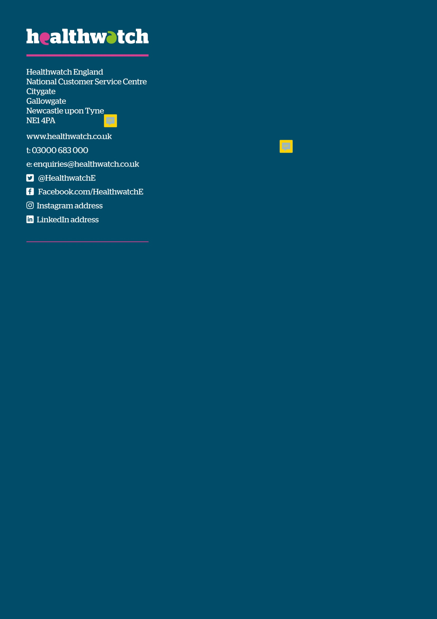 @HealthwatchE

 Facebook.com/HealthwatchE